Outputs for lab 3 submission

# Question 1:

Explain the output of this C program. Why the wrong value is being displayed in the output?

### Answer:

The output of the C program is being displayed wrong because the 'testvariable' has a datatype of int, which has a range from -2,147,483,648 to 2,147,483,647, has been initialized to the value of 3000000000 that is not in the range of int datatype.

# Question 2:

Write a C program that takes two integer values as input from the user. Then swap the values taken from the user and display the output of the variables.

### Output:

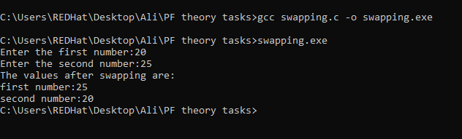

# Question 3:

A customer asks the IT firm to develop a program in C language, which can take tax rate and salary from the user on runtime and then calculate the tax, the user has to pay and the salary he/she will have after paying the tax. This information is then provided to the user.

### Output:

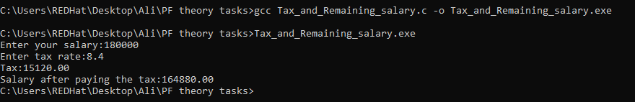

# Question 4:

A car travelled back and forth from point A to point B. With a distance being (single trip) 1207KM. During the forward trip fuel price was 118/liter while returning it was 123/liter. Calculate the total fuel cost (both ways) and the fuel consumed (total trip). Use the car’s fuel average as input from the user (Input must be positive make some restrictions on only accepting positive input)

### Output:

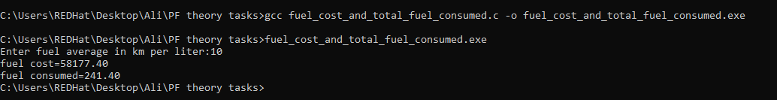

# Question 5:

Construct a C program with the flowchart below. The input value of the principle must be between 100 Rs. To 1,000,000 Rs. The Rate of interest must be between 5% to 10% and Time Period must be between 1 to 10 years. Hint: these restrictions can be displayed in the form of message on the window.

### Output:

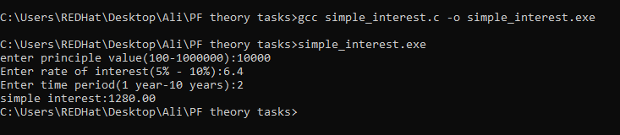

# Question 6:

Construct a C program where you calculate the slope of two point (5,4), (3,2). Use format specifiers to cap the result to 3 decimal places.

### Output:

